

Group: C1.010

García Rivero, Andrés Francisco -[andgarriv@alum.us.es](mailto:andgarriv@alum.us.es)

López Cubiles, Antonio José - [antlopcub@alum.us.es](mailto:antlopcub@alum.us.es)

Nieto Vicioso, Javier - [javnievic@alum.us.es](mailto:javnievic@alum.us.es)

Díaz Ordoñez, Pablo -  [pabdiaord@alum.us.es](mailto:%20pabdiaord@alum.us.es)

Sevillano Barea, Alejandro - [alesevbar@alum.us.es](mailto:alesevbar@alum.us.es)

April 26th, 2024

Analysis Report

**Repository: https://github.com/C1-010/Acme-SF-D03**

Contenido

1. Executive Summary 2

2. Revision Table 2

3. Introduction 2

4. Contents 2

4.1. Information requirements……………………………………………………………………………………..2

4.1.1. Mandatory

4.1.2. Supplementary

4.2. Functional requirements……………………………………………………………………………………….2

4.2.1. Mandatory

4.2.1. Supplementary

4.3. Non-functional requirements………………………………………………………………………………..2

4.3.1. Mandatory

4.3.2. Supplementary

4.4. Testing requirements……………………………………………………………………………………..……..2

4.4.1. Mandatory

4.4.2. Supplementary

4.5. Managerial requirements……………………………………………………………………………….……. 3

4.5.1. Mandatory

4.5.2. Supplementary

5. Conclusions 3

6. Bibliography 3

# 1. Executive Summary

This document will gather an analysis of the most complex requirements included in this deliverable. Within the analysis of each requirement, the requirement itself will be quoted verbatim, and the decisions made to fulfil said requirement will be included.

# 2. Revision Table

|  |  |  |
| --- | --- | --- |
| Revision number | Date | Description |
| 1 | 26/04/2024 | Document created and completed |

# 3. Introduction

The purpose of this document is to perform an analysis of the requirements deemed necessary, providing a detailed description of each. Additionally, different available options will be identified, if any, to address each requirement, along with the associated advantages and disadvantages of each. Finally, the chosen alternative will be presented.

# 4. Contents

**4.1. Information requirements**

**4.1.1. Mandatory**

Intentionally blank

**4.1.2. Supplementary**

Intentionally blank.

**4.2.** **Functional requirements**

**4.2.1. Mandatory**

*9) Operations by any principal on claims:*

*· List the claims and show their details.*

*· Publish a claim. This operation requires confirmation because claims cannot be updated or deleted.*

*10) Operations by any principals on banners:*

*· Display any of them randomly, as long as its display period is active; the banners must be shown in every page as little intrusively as possible.*

*11) Operations by administrators on banners:*

*· List the banners and show their details.*

*· Create, update, or delete a banner.*

These requirements were not excessively complex for us, but we did have to pay close attention to the Acme Jobs project and what we already had implemented in our project. The slides that were uploaded related to deliverable 3 were also very useful to us when implementing these requirements.

**4.2.2. Supplementary**

Intentionally blank

**4.3. Non-functional requirements**

**4.3.1. Mandatory**

*12) Moments, money amounts, and Booleans must be internationalised when they are shown. Other kinds of data are not expected to be internationalised. This requirement must be fulfilled in this and every subsequent group or individual deliverable for it to be considered valid.*

**Requirement 12-Group requirement**

**Verbating copy of the requirement:** Moments, money amounts, and Booleans must be internationalised when they are shown. Other kinds of data are not expected to be internationalised. This requirement must be fulfilled in this and every subsequent group or individual deliverable for it to be considered valid.

This requirement raised many doubts for me since some of the issues requested seemed to be already covered by the framework and the project itself. That's why we asked the client and consulted the forum to clarify if my understanding was correct.

 To do this, I proposed two alternatives similar to those discussed in the forum. On one hand, we have **alternative 1**, which suggests not adding anything more to the project, as this requirement is already fulfilled by the framework's own characteristics and the project's. Therefore, we consider the requirement completed, with the main advantage being a time gain to address other requirements. On the other hand, we have **alternative 2**, which involves implementing internationalization, something that would create many problems and consume a lot of time, without a clear idea of how to proceed.

**Conclusion:** Alternative 1 is presented as the proposed solution and definitive choice. Requirement 12 is already implemented.

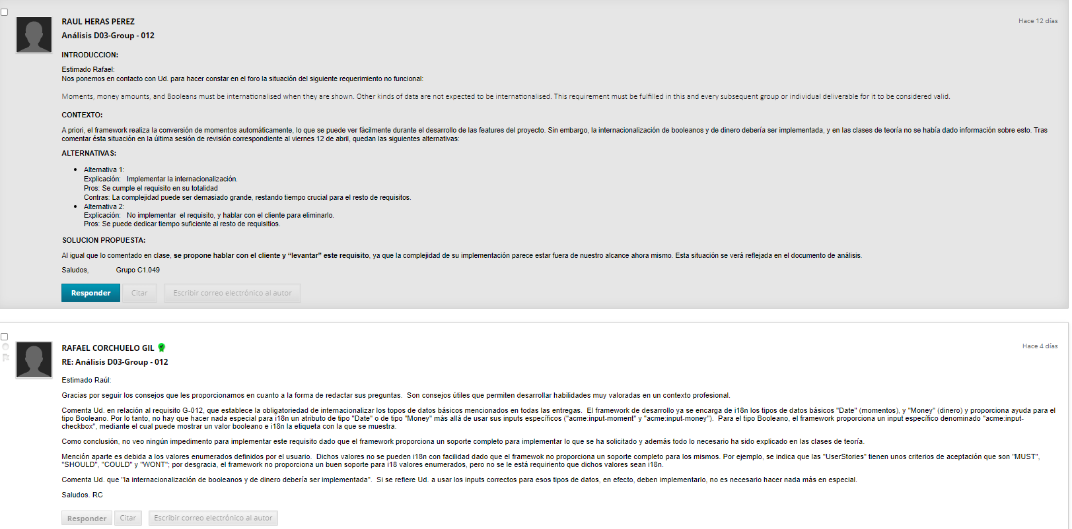

**4.3.2. Supplementary**

Intentionally blank

**4.4. Testing requirements**

**4.4.1. Mandatory**

Intentionally blank

**4.4.2. Supplementary**

Intentionally blank

**4.5. Managerial requirements**

**4.5.1. Mandatory**

Intentionally blank

**4.5.2. Supplementary**

*35) Produce an analysis report.*

*36) Produce a planning and progress report.*

*37) Produce a lint report*

The analysis report and the planning and progress report have been easy for us since we have looked at how we had developed them in previous deliverables.

To make the lint report we have relied on the guidelines written by Rafael Corchuelo in the "Tutorials" forum

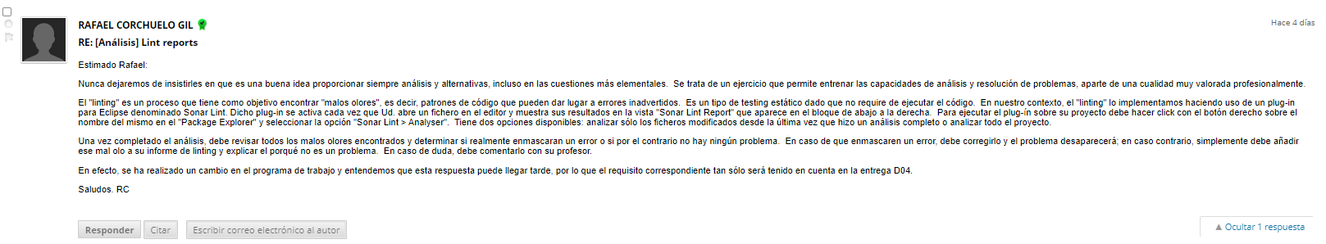

# 5. Conclusions

In conclusion, the analysis of the requirements for this deliverable has been simple thanks to the information they give us with Acme Jobs and the slides related to deliverable 3, but this time it has taken us longer to implement them than in deliverable 2. Again we have required the search for alternative solutions such as the "Tutorials" forum.

# 6. Bibliography

"08 Annexes.docx" - Material provided in the DP2 subject at the University of Seville.Principio del formulario